Plant Transport Notes
All organisms respire (well, nearly all, but according to your syllabus they all do). Therefore, all organisms need to exchange gases with their environment.
Unicellular organisms: exchange gases directly through their cell membrane. They can do this because their surface area is large compared to their volume (large SA:Vol ratio). They do not need a circulatory system.
Multicellular organisms: cannot exchange gases directly through their skin. Their surface area is very small compared to their volume (small SA:Vol ratio); therefore, they need to have specialized gas exchange organs (e.g. leaf, lung and gill) and a circulatory system.
Transport in Flowering plants:
Plants have two different networks of tubes inside them;
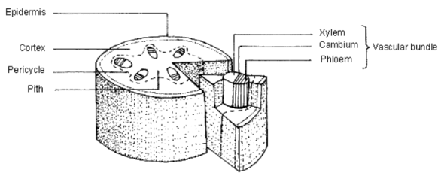
Phloem: transports sucrose and amino acids up and down the stem
Xylem: transports water and minerals up the stem
Phloem and Xylem are arranged in separate bundles (vascular bundles) inside the stem. The xylem is on the inside and the phloem is on the outside. This arrangement is different in roots (but you don’t need to know it)
Transport in the phloem is tricky, but fortunately not on your syllabus. It is not the same as transport in the xylem, which occurs by the process of transpiration.
Transpiration is the movement of water up a plant, from the roots, through the stem and finally out of the leaves.
In the Roots:
Water enters root hair cells by osmosis. The roots are full of minerals, which artificially lower the concentration of water inside the root cells, so water is always drawn into them from the soil. This enables transpiration to happen even if the soil is very dry. The roots take the minerals up against the concentration gradient and is, therefore, an example of active transport.
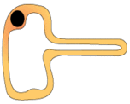
Root hair cells increase the root’s surface area
In the Stem:
1. Water evaporates out of the top of the xylem
2. This generates a low pressure at the top of the xylem (a mini vacuum, if you like)
3. This sucks water molecules up the xylem
4. This is called transpiration pull
Extension (not on syllabus, but very interesting…)
Water molecules are slightly charged (polar). The oxygen atom is slightly negative and the hydrogens are slightly positively charged. This means that water molecules tend to stick to each other. Therefore, when transpiration pull sucks at the water molecules in the top of the xylem, the entire column of water moves up the xylem, not just the molecules at the top!
In the leaf:
Water enters the leaf in xylem vessels in veins (basically, another name for a leaf vascular bundle). The water moves by osmosis into leaf mesophyll cells, where it evaporates into the air spaces and finally diffuses out of the stomata into the air.
Factors affecting the rate of transpiration:
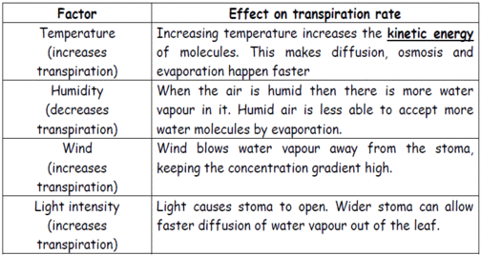
You need to know an experiment that can show the effect of the above factors on the rate of transpiration. The best experiment is a potometer, which measures how quickly a little bubble of air moves up a glass tube attached to the bottom of the stem. Adding a fan, changing the humidity, increasing the temperature etc will all change the speed the bubble moves up the tube.
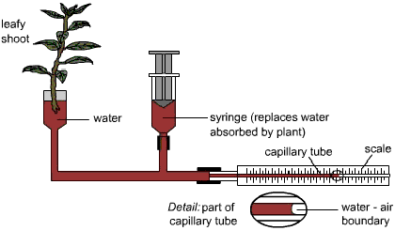
Why do plants need water (why do they bother to transpire)?
- Used in photosynthesis (~10%)
- A solvent for transporting other things (e.g. minerals) (~10%)
- Used in chemical reactions (~5%)
- A site of chemical reactions (~5%)
- Cooling the plant (~70%)

