Armpit cheese: The sweeter side of bacteria
- 01 January 2014 by Richard Fisher
- Magazine issue 2948. Subscribe and save
- For similar stories, visit the Micro-organisms and Food and Drink Topic Guides
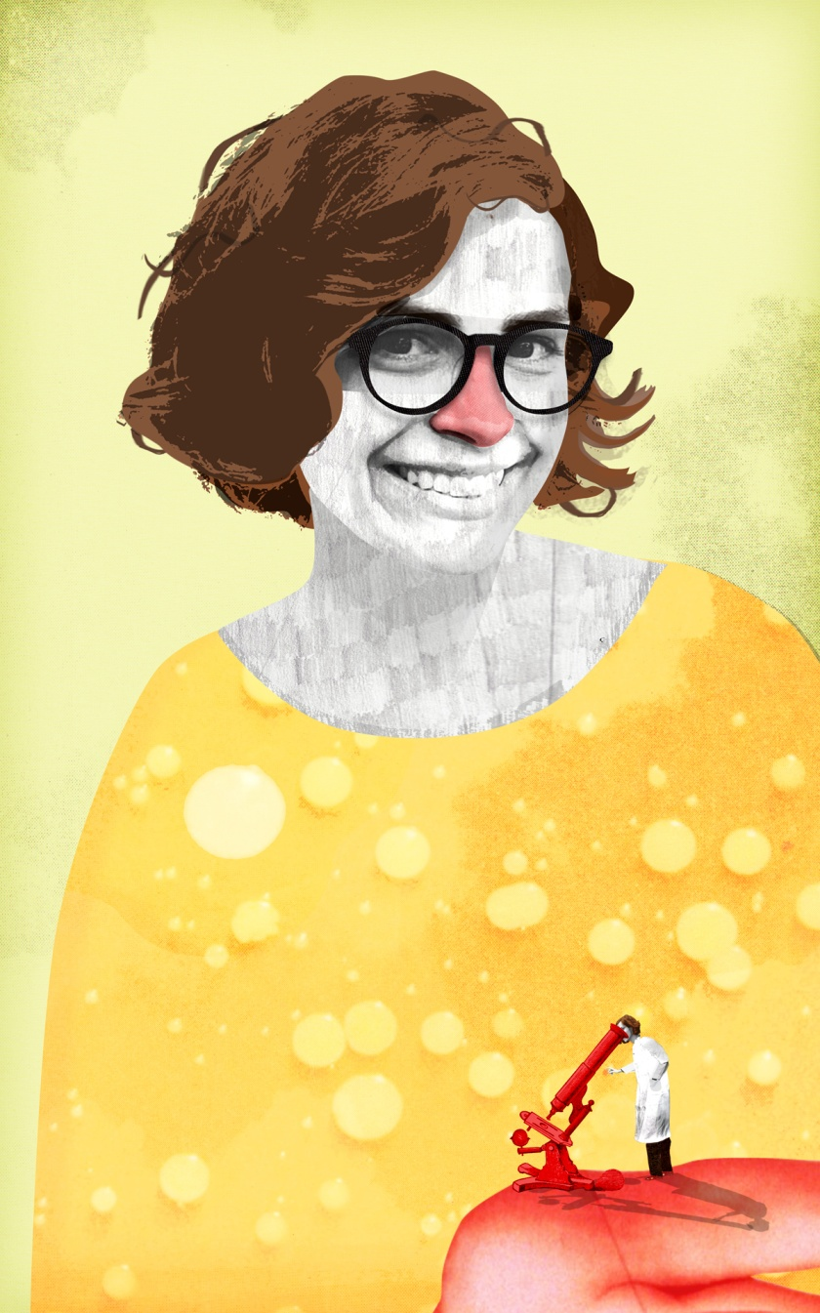
Would you eat cheese cultivated from your armpit sweat or toe jam? No? Then you should rethink your prejudices about bacteria
CHRISTINA AGAPAKIS stood in her kitchen trying to decide whether she had the nerve to eat what was in front of her. On the worktop sat four blobs of cheese – but not just any stinky fromage. Agapakis, who is a synthetic biologist at the University of California, Los Angeles, had made the stuff with bacteria from her armpit, nose and toes.
"Each one had a very different smell," she says. "Some were dry and brittle and yellow, others were more yogurty". Surely she wouldn't dare taste it. Would she?
Agapakis picked up a chunk and popped it in her mouth. If you're wondering why anybody would do such a thing, well, she has her reasons. Agapakis is on a mission to change our ideas about the role of microbes in food production and elsewhere – and she's not the only one.

Christina Agapakis wants to make more of microbes (Image: Sam Flaconer)
She and other researchers join chefs, food producers and even a nun who argue that our attitude to bacteria in food is far too prissy. "It's about understanding that we have allies as well as foes in the microbial world," says anthropologist Heather Paxson at the Massachusetts Institute of Technology, who has studied this ultra pro-bug movement.
Their message goes much further than pointing out how bacteria are handy for tasks like culturing yogurt. They want to tell the whole story about microbes, and everything they do for flavour, nutrition and health – including our mental well-being.
Reinventing the bacterium's public image will be no mean feat. Contemporary culture – especially in advertising – is geared towards ruthless eradication. Soap isn't just soap any more, it is antibacterial hand wash. Body odour must be banished at all costs. Even the "good" bacteria in probiotic drinks are advertised as sanitised versions of the biological reality.
Of course, we have reason to fear bugs and microbes – they often make us ill. But some think this bacteria-blaming has gone too far, and nowhere more so than when it comes to food. Among the first to resist the germ-free dogma was a nun who likes to make Camembert.
Noella Marcellino at the Abbey of Regina Laudis in Connecticut has been a big cheese among fromage fans ever since she locked horns with the US Food and Drug Administration more than a decade ago. The FDA is tough on cheesemakers, insisting that they only use pasteurised milk, and age their cheeses at least 60 days to kill off bad bugs. But these regulations also wipe out the beneficial bacteria that give certain cheeses their flavour. Marcellino collided with these rules when an inspector demanded that she use a sterile steel container to make her cheese instead of the bacteria-ridden wooden barrel she had used for years. The FDA's worry was nuns with the runs.
Unfazed, Marcellino studied for a microbiology doctorate. Eventually, after running experiments, she showed her inspector that cheese from the steel vat was prone to E. coli contamination – but not so for the barrel. "Good bacteria were growing in the wood," she told The New Yorker. This community staved off nasty microbes while contributing to the cheese's unique taste.
Since then, the idea that we should harness the harmless bacteria that set up home in food-production facilities has caught on. For example, Rachel Dutton and Benjamin Wolfe of Harvard University are conducting the biggest ever microbial census of cheese, with the aim of linking specific communities to flavours. Their work has attracted the attention of chefs at Momofuku, a restaurant in New York, who are looking to maximise the flavour of fermented dishes such as kimchi and miso. Meanwhile, "fermentation revivalists", such as author Sandor Katz, are advocating the nutritional value of decomposing vegetables.
For some, though, more drastic efforts are required. Agapakis and Sissel Tolaas, an artist in Berlin, make cheese using microbes from their own bodies. Would you want to eat it? Probably not, but that's not the point.
The project began when the pair were scrutinising the chemicals that make up body odour. They realised that the bacteria responsible weren't so different from those used in cheesemaking. Inspired, they rushed to the supermarket to buy a gallon of milk. Using cotton buds, they swabbed their nose, mouth, armpit and toes – "the moister, the better", as Agapakis puts it. They weren't sure this would work, because they were swabbing an entire community of microbes, rather than specific ones known to aid cheesemaking. But they left the buds in warmed milk and waited overnight.
In the first stage of making cheese, milk is transformed into curds and whey via bacteria such as Lactobacillus. This produces lactic acid, which coagulates the milk protein casein. Lactobacillus is also plentiful in the mouth, among other places.
The body bacteria seemed to be doing the work. The next day, Agapakis and Tolaas discovered that curds had begun to form. That's the crucial stage, and after that it's a matter of draining the curds and ripening them into cheese. "It was interesting how diverse they were," says Agapakis. "Each bacterial community had a very different effect on the milk." For example, nose cheese turned out to be yellower and more crumbly than the creamier varieties from elsewhere.

Mouth mozzarella
That is not so surprising. In normal cheesemaking, different bacteria – many of which are also found on the body – result in very different cheeses. Limburger gets its smell and orange colour from Brevibacterium linens, a close relative of Brevibacterium epidermidis, which is found on the skin. And the holes in Swiss cheese come from carbon dioxide given off by Propionibacterium freudenreichii, a contributor to armpit odour.
But isn't this disgusting project counterproductive? It hardly works as an advert for the cheese industry. By now, you may well be put off Emmental from a supermarket, let alone the body.
Agapakis sees it like this: these microbes might never be loved – and it takes willpower to see them as delicious – but they should be lauded for what they can do, in all their yucky diversity. When she shows off the cheese in public, as she did in October at the Science Gallery in Dublin, Ireland, it tends to win attention for the shock factor. This allows her to highlight the benefits of bacteria: their countless uses in industry, and vital roles in and on the body. A range of recent studies has shown that bodily microbes do everything from regulate hormones to promoting happiness. Mycobacterium vaccae, for instance, triggers an immune response that causes a release of serotonin, boosting your mood.
"There's a reductionist idea that we can get rid of the 'dirt' in biology and that it'll still work," says Agapakis. "But it's about understanding that there is all this life everywhere. And that, in its complexity, is what makes us strong and healthy."
So how many of their cheeses did they dare to taste? "There were some, based on the smell, I wouldn't try, they didn't smell good," says Agapakis. But when she bit into a chunk of mouth cheese, she was pleasantly surprised. It tasted like fresh mozzarella. She decided to eat something else for lunch, though.
This article appeared in print under the headline "Curd your enthusiasm"

